## Patient Name NHS Number Date

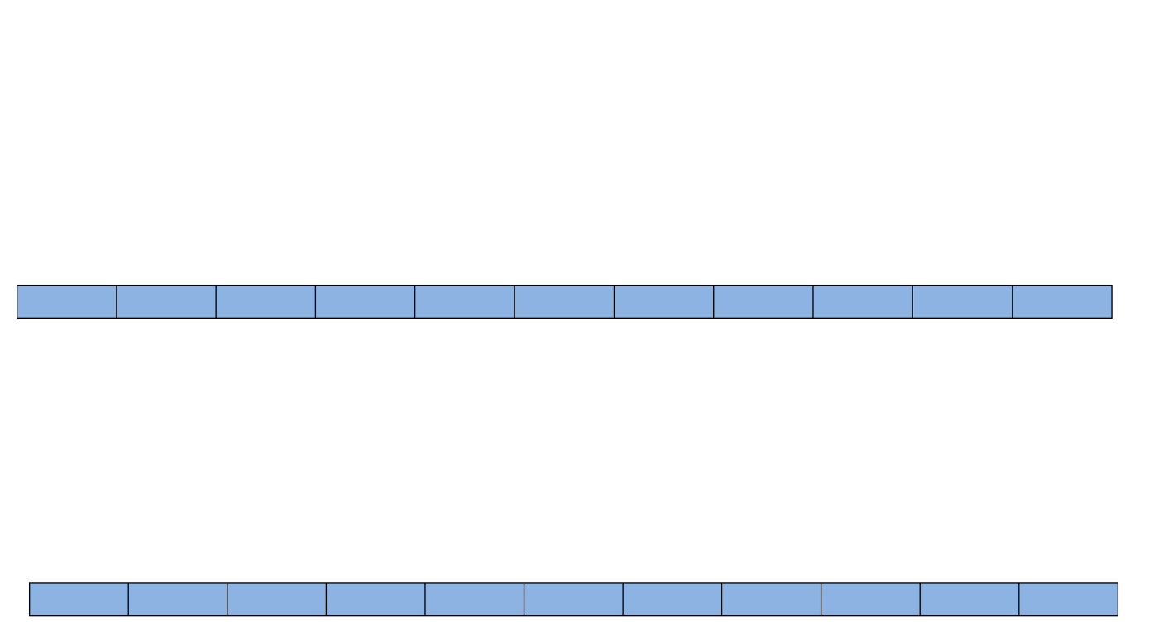

**Pain Intensity and Interference**

In the last month, on average, how would you rate your pain? (That is your usual pain at

times you were in pain.)

Use the scale from 0 to 10, where 0 is “no pain” and 10 is “pain as bad as it could be”

**As bad as pain could be**

**0 1 2 3 4 5 6 7 8 9 10**

In the last month, how much has pain interfered with your daily activities? Use a scale

from 0 to 10, where 0 is “no interference” and 10 is “unable to carry on any activities”

**0**

**1**

**2**

**3**

**4**

**5**

**6**

**7**

**8**

**9**

**10**

**Unable to carry**

**on any activities**

**No Interference**

**No pain**

PHQ4 plus 2

|  |  |  |  |  |
| --- | --- | --- | --- | --- |
| **Over the past few weeks have you been bothered by these problems?** | **Not at all** | **Several days** | **More days than not** | **Nearly every day** |
| **Feeling nervous, anxious, or on edge** | 0 | 1 | 2 | 3 |
| **Not be able to stop or control worrying** | 0 | 1 | 2 | 3 |
| **Feeling down, depressed, or hopeless** | 0 | 1 | 2 | 3 |
| **Little interest or pleasure in doing things** | 0 | 1 | 2 | 3 |

**Health Needs Assessment Changing how pain affects your life**

Pain can affect peoples’ lives in many ways. This check list shows some of the problems and difficulties due to longstanding pain.

Please help us understand the main problems **at present** that **you** feel are important to improve your quality of life and self-manage with more confidence.

Please follow the two steps below and tick ✓ the boxes below related to your needs.

## Name: Date of birth:

|  |  |  |
| --- | --- | --- |
| **STEP 1** | **Do you have any problems or difficulties with:** | |
|  | 1 | * Walking or moving about |
| 2 | * Lack of fitness and stamina |
| 3 | * Balance or recurrent falls |
| 4 | * Side effects or other problems with current pain medication e.g. tablets etc. |
| 5 | * Pain symptoms or pain relief |
| 6 | * Understanding why longstanding pain occurs |
| 7 | * An unhelpful pattern of activity of doing too much, getting more pain, then doing too little |
| 8 | * Eating the right sort of foods |
| 9 | * Disturbed sleep |
| 10 | * Managing mood changes of depression, anger, anxiety or worry |
| 11 | * Tiredness or lack of energy |
| 12 | * Relationship difficulties; with partner, family, work etc. |
| 13 | * Sex life |
| 14 | * Remaining in work or returning to work and/or training |
| 15 | * Financial or money difficulties |
| 16 | * Current legal claim linked with the pain problem |
| 17 | * Concerns about your carer/partner, their health or other problems |
| 18 | * Other difficulties that you feel are important to change, for example, concerns about housing, hobbies, leisure or social events with friends or visiting the church or mosque. Please describe here: |
| **STEP 2** | If you ticked more than **three areas of your life**, please **circle the three** most important to change at present.  Thank you for helping us to understand your needs and issues due to pain. | |
|  |

HNAtool260613

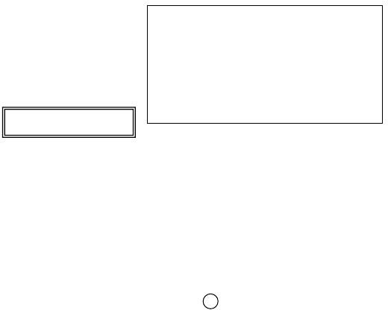Name:

Date of Birth:

NHS No:

# PSEQ

Date…………………

# 1) Managing your pain

Please rate **how confident** you are that **you can do** the following things at present, **despite the pain.** To answer, **circle** *one* of the numbers on the scale under each item, where 0 = "Not at all confident" and 6 = "Completely confident".

**For example:**

**Not at all confident**

**Completely confident**

0 1 2 3 4 5 6

Remember, this questionnaire is not asking whether or not you have been doing these things, but rather **how confident you are that you can do them** at present, **despite the pain.**

**Not at all confident**

**Completely confident**

I can enjoy things, despite the pain.

0 1 2 3

4 5 6

7

|  |  |  |  |  |  |  |
| --- | --- | --- | --- | --- | --- | --- |
| housework, paid and unpaid work). 0 | 1 | 2 | 3 | 4 | 5 | 6 |
| I can still do many of the things I enjoy doing, such as hobbies |  |  |  |  |  |  |

|  |  |  |  |  |  |  |  |
| --- | --- | --- | --- | --- | --- | --- | --- |
| I can do most of the household chores (eg. tidying-up, washing dishes, etc.) despite the pain. | 0 | 1 | 2 | 3 | 4 | 5 | 6 |
| I can socialise with my friends or family members as often as I used to do, despite the pain. | 0 | 1 | 2 | 3 | 4 | 5 | 6 |
| I can cope with my pain in most situations. | 0 | 1 | 2 | 3 | 4 | 5 | 6 |
| I can do some form of work, despite the pain ("work” includes |  |  |  |  |  |  |  |

|  |  |  |  |  |  |  |  |
| --- | --- | --- | --- | --- | --- | --- | --- |
| or leisure activities, despite the pain. | 0 | 1 | 2 | 3 | 4 | 5 | 6 |
| I can cope with my pain without medication. | 0 | 1 | 2 | 3 | 4 | 5 | 6 |
| I can still accomplish most of my goals in life, despite the pain. | 0 | 1 | 2 | 3 | 4 | 5 | 6 |
| I can live a normal lifestyle, despite the pain. | 0 | 1 | 2 | 3 | 4 | 5 | 6 |
| I can gradually become more active, despite the pain. | 0 | 1 | 2 | 3 | 4 | 5 | 6 |